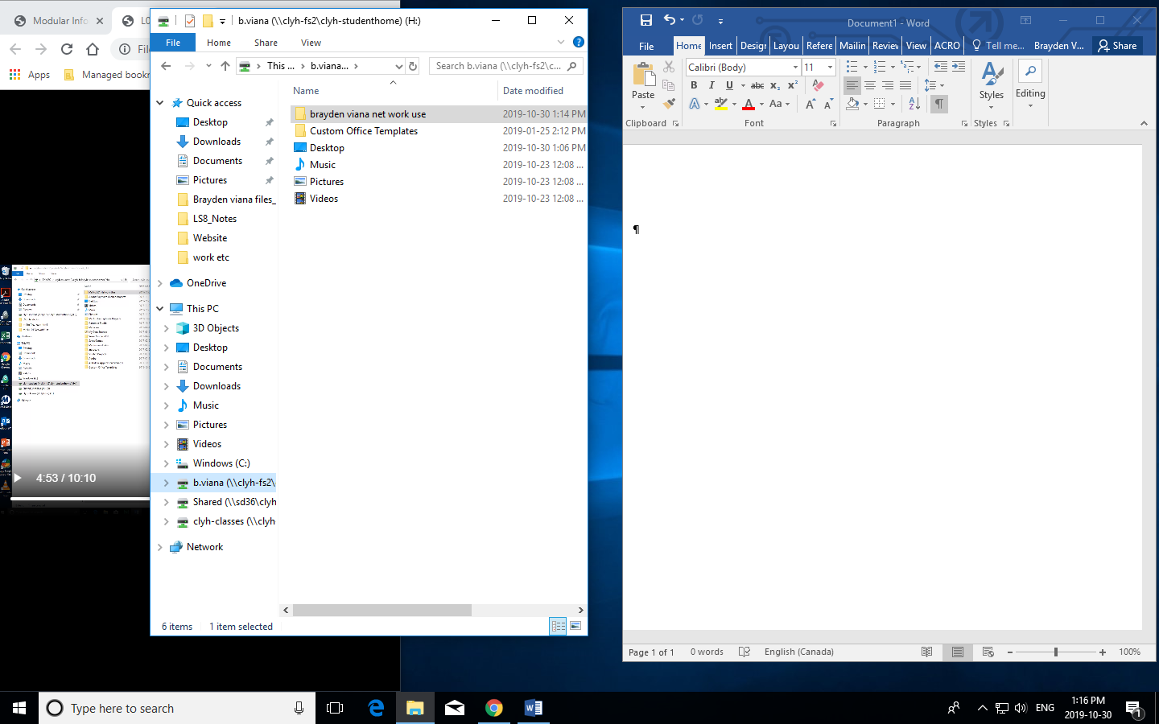

MY H drive

Here is 1hrs work